DATE: October 15, 2024 FOR IMMEDIATE RELEASE

CONTACT: Aaron McConkey, OPW Senior Marketing Manager
aaron.mcconkey@opwglobal.com or +44 7854 048 194

KPS Releases New 3”
Double Wall HDPE Piping System

Kungsör, Sweden, October 14, 2024 — KPS, part of OPW, a Dover company and a global leader in the development of plastic piping for sensitive fluids like fuels, is proud to announce its new 3” (110/90 mm) double wall HDPE piping system. Designed to meet customer demand, the new 3” system is engineered for medium to high flow applications on forecourts, data centres and backup and primary generators including fill lines and other fuel and vapour lines where the highest standards are required.
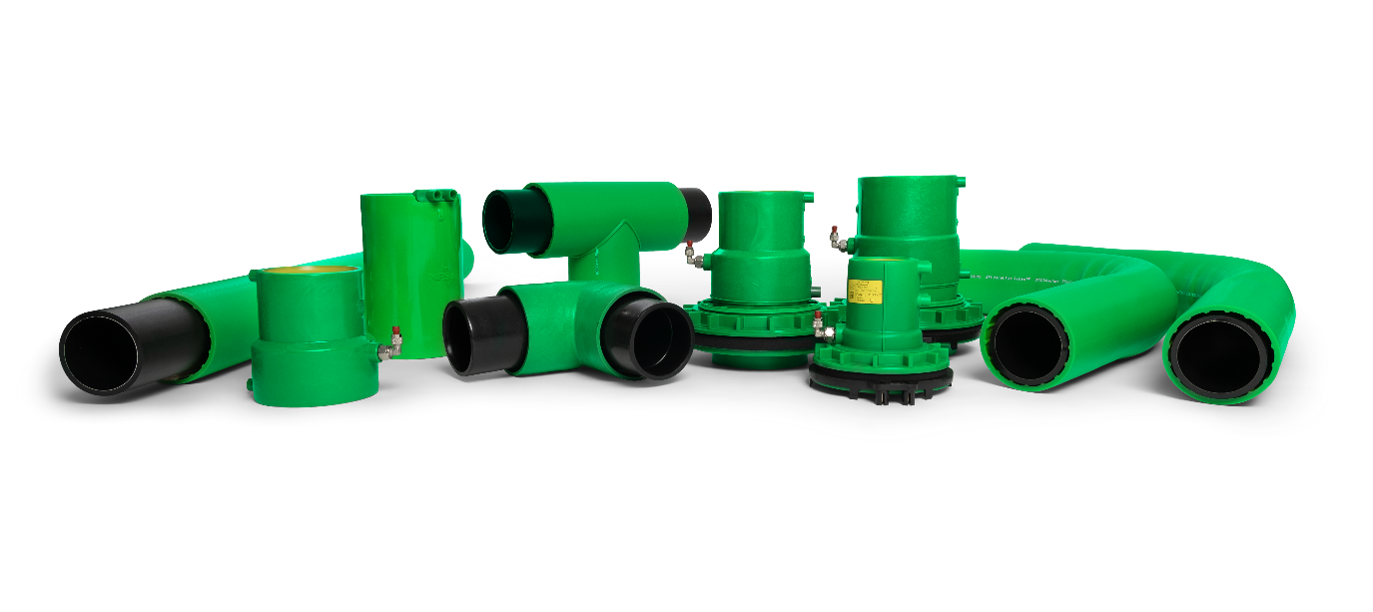
“Our new 3” system expands the KPS portfolio even further, offering customers a range of double wall piping to suit any application, including 1”, 2”, 4”, and 6”. Carefully designed by the KPS technical engineering team in Kungsör, Sweden (the home and birthplace of KPS), the 3” system has the same easy-install conductive properties KPS piping is known for.”
Staffan Helleday, KPS Product Manager

EN 14125 Approved
Certified to EN 14125, the KPS 3” system consists of a 90 mm primary containment pipe and a 110 mm secondary containment pipe, providing an extra layer of protection and enabling interstitial monitoring. The zero-permeation design includes an EVOH layer and is designed for sensitive liquids like fuels and chemicals, including petrol, diesel, biodiesel, ethanol blends, AdBlue, Jet-A1, alcohols, acids and other chemical products.
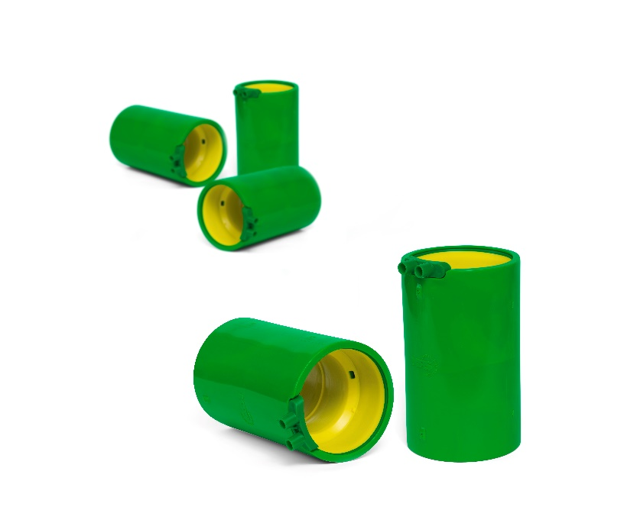
Engineered for Easy Installation
Like all KPS piping, the new 3” system is engineered for installers to reduce cost and build time. The complete range of fittings and components are electrofusion welded, with no butt welds needed, and supported by the KPS technical team, including training and certification (classroom and on-site).
For more information on the KPS 3” piping system, please visit the KPS website at www.kpspiping.com/
KPS’ installer friendly 3” double wall fittings weld both pipe walls simultaneously
ENDS

About KPS
Since 1996, KPS has led the development of plastic petroleum/fuel pipe systems on or used in forecourts around the world with safe, reliable and installation-friendly piping. Today the KPS Plastic Pipe System is sold and installed across Europe, the Middle East, Asia, China, South America and Africa to make sensitive fluids flow safely. KPS’ double wall Polyethylene piping is the most popular choice among forecourt installers and piping designers thanks to smart, lightweight and compact solutions that make piping design and installation easier than ever; providing a long-lasting solution that’s liquid/water tight and corrosion-free. Since 2013, KPS has been a part of OPW (a Dover company) allowing us to offer an unprecedented portfolio of complementary best-in-class products. To learn more about KPS, visit kpspiping.com.

