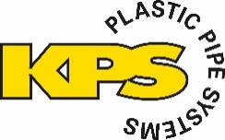
KPS Introduces Lightweight Electrostatically Safe 6” Piping System To Make High-Flow Fuel & Chemical Transport Simpler & Safer

This new system, a world first, has been designed to combine KPS piping’s industry-leading safety and installer-friendly qualities with a high flow rate of up to 2,500 litres/minute to meet demand from applications including depots, fuel distribution, ports, mining, rail, data centres and many more.
The Importance Of Conductive Piping
‘When fuel flows through a pipe, it creates friction, creating an electrical charge on the pipe wall. If the material is not conductive, the charges (free electrons) can’t flow anywhere and consequently accumulate until a rapid discharge can occur: a spark!
In 1997, we developed the world’s first conductive HDPE piping to combine the lightweight, corrosion-free benefits of HDPE with the conductive safety of metal. A conductive inner layer allows static electricity to dissipate into the earth.
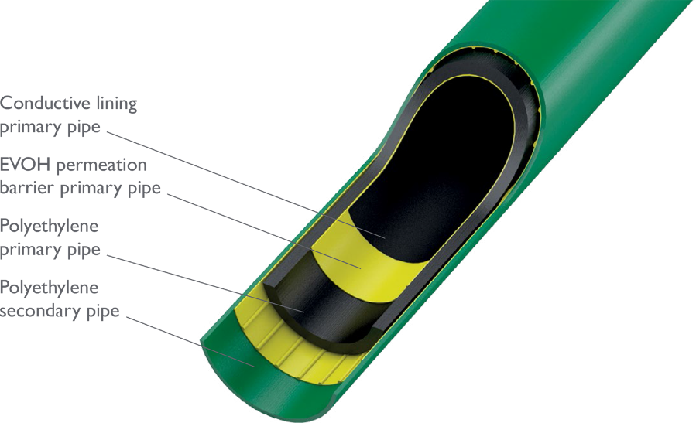
Now, a number of countries, including China, Germany, Slovenia, Croatia and the Baltic States, require conductive piping to be used for filling stations, as well as a number of major oil companies, including BP, OMV, PetroChina, Q8, Aral, Total and Esso. As future fuels containing oxygen which generate more friction are increasingly used, conductive piping becomes ever more important. ‘
Staffan Helleday, Technical Director, KPS
A conductive inner layer allows static electricity to safely dissipate into the earth, while a secondary pipe provides an extra layer of protection and enables interstitial monitoring.

High Flow, High Performance
KPS’ new 6" double wall conductive piping system provides flow rates up to 2,500 litres/minute, the highest flow rate available in the KPS piping portfolio. This innovative conductive system consists of a 160mm primary pipe and a 200mm secondary pipe, providing an extra layer of protection and enabling interstitial monitoring. Suitable for sensitive liquids like fuel and chemicals, including petrol, diesel, biodiesel, ethanol blends, AdBlue, Jet-A1, alcohols, acids and other chemical products. The system is approved to EN 14125, ATEX 137, EN 13463-1, as well as many other country and fuel-specific standards.
Engineered For Easy Installation
Like all KPS piping, the new 6” system is engineered for installers to reduce cost and build time. The complete range of fitting and components for the new 6" conductive double wall pipe system are electrofusion welded, with no butt welds needed, and the range is supported by the KPS technical team, including training and certification (classroom and on-site).
‘We’re excited to launch another KPS world first: the 6” piping range, centred around making fuel transport safer and installation easier.’
Aaron McConkey, Marketing Manager, OPW (KPS’ parent company)
Visit the KPS website for more information

OPW Contact:
Aaron McConkey
+44 (0) 1756 799 773
aaron@fibrelite.com

